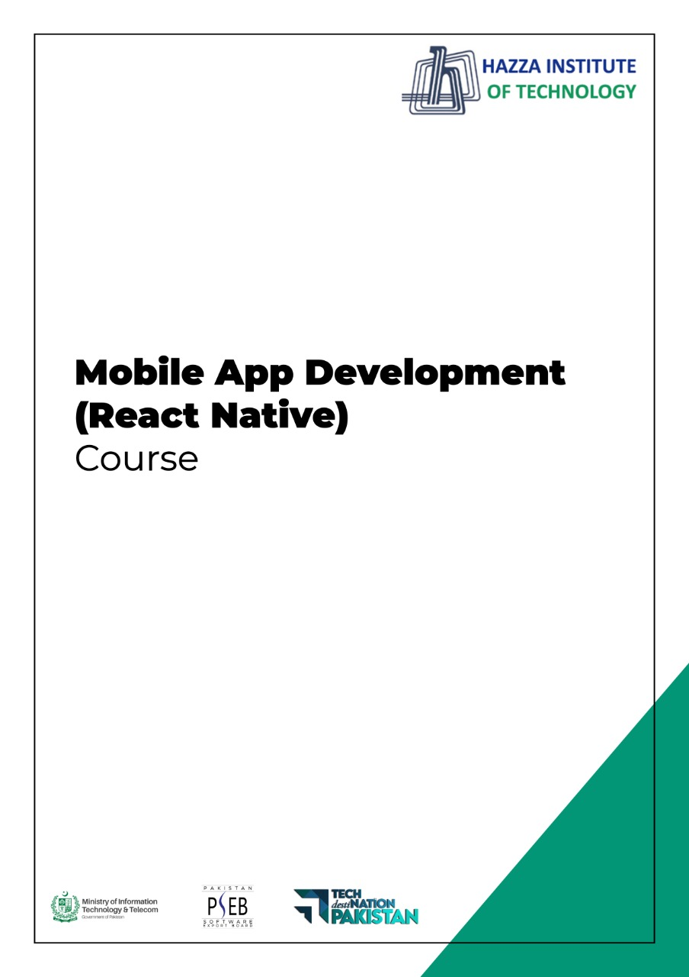
(Flutter)
Flutter Lab 3 (Session 1)

Total Time:
3 hours (session-1)

Pre-Lab Activities:
  - Basics of Flutter
  - Familiar with Android Studio and Flutter Application Mode
  - Familiar with Layout Widgets

Learning Outcomes:
- Demonstrate the knowledge of Flutter to design stateful, cross-platform, and interactive user interfaces for mobile applications.

Student Activities:
- Student create a new flutter project in Android Studio and Write the code for above application.

Lab Tasks 1:
  - Modify the default application, which you access, when you first time create a new project. You have only change the background color.
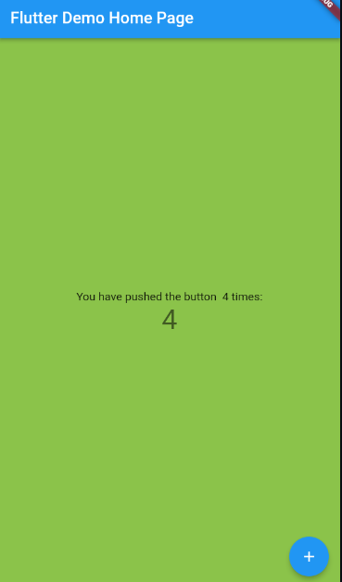

Lab Tasks 2:
  - Modify the code used to develop above task. Remove stateless and statefull classes and use the main function to develop the same app again with displaying a simple Text “Hellow Word”.
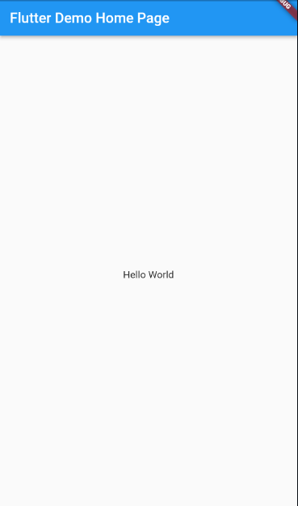

Lab Solutions:

LAB 3.1 : Practicing Basic Flutter application design.,
CODE:
import 'package:flutter/material.dart';

void main() {
runApp(MyApp());
}

class MyApp extends StatelessWidget {
// This widget is the root of your application.
@override
Widget build(BuildContext context) {
return MaterialApp(
title: 'Flutter Demo',
theme: ThemeData(
primarySwatch: Colors.blue,
),
home: MyHomePage(title: 'Flutter Demo Home Page'),
);
}
}

class MyHomePage extends StatefulWidget {
MyHomePage({Key? key, required this.title}) : super(key: key);

final String title;

@override
_MyHomePageState createState() => _MyHomePageState();
}

class _MyHomePageState extends State<MyHomePage> {
int _counter = 0;

void _incrementCounter() {
setState(() {
_counter++;
});
}

@override
Widget build(BuildContext context) {
return Scaffold(
backgroundColor: Colors.lightGreen,
appBar: AppBar(
title: Text(widget.title),
),
body: Center(
child: Column(
mainAxisAlignment: MainAxisAlignment.center,
children: <Widget>[
Text(
'You have pushed the button $_counter times:',
),
Text(
'$_counter',
style: Theme.of(context).textTheme.headline4,
),
],
),
),
floatingActionButton: FloatingActionButton(
onPressed: _incrementCounter,
tooltip: 'Increment',
child: Icon(Icons.add),
), // This trailing comma makes auto-formatting nicer for build methods.
);
}
}

LAB 3.2 : Practicing Basic Flutter application design.,
CODE:
import 'package:flutter/material.dart';
void main() => runApp(MaterialApp(
title: 'Flutter Demo',
theme: ThemeData(
primarySwatch: Colors.blue,
),

home: Scaffold(
appBar: AppBar(
title: Text('Flutter Demo Home Page'),
),
body: Center(
child: Text("Hello World"),
),
),
));

